Evaluating the use of whisker spot patterns as a non-invasive method of individual identification of seals and sea lions

RESEARCH UPDATE

The testing of pattern “uniqueness” of whisker spot patterns has begun! 31 photos from six individual Australian sea lions have been imported into Matlab so far. Iain Parnum, research fellow at CMST, wrote some great codes for Matlab to rotate, resize and overlay a grid of a specific size onto the imported photo. The corner of the eye and the nostril were used as reference points so that photos are comparable to each other after crossing the cells including a whisker spot. The position of the whisker spots have been manually identified and recorded (photograph below), and the presence and absence of these spots in the grids documented.

Here the single steps:
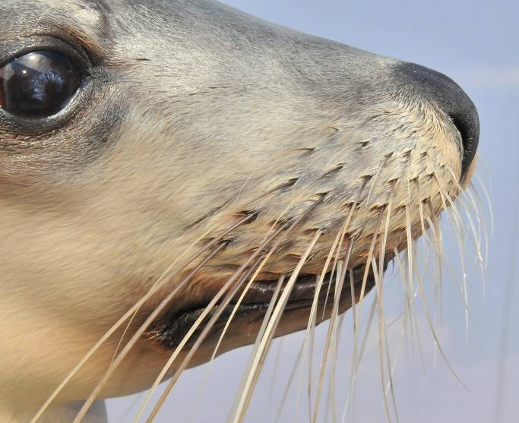
Figure 1. Original sea lion photo from one of the zoos

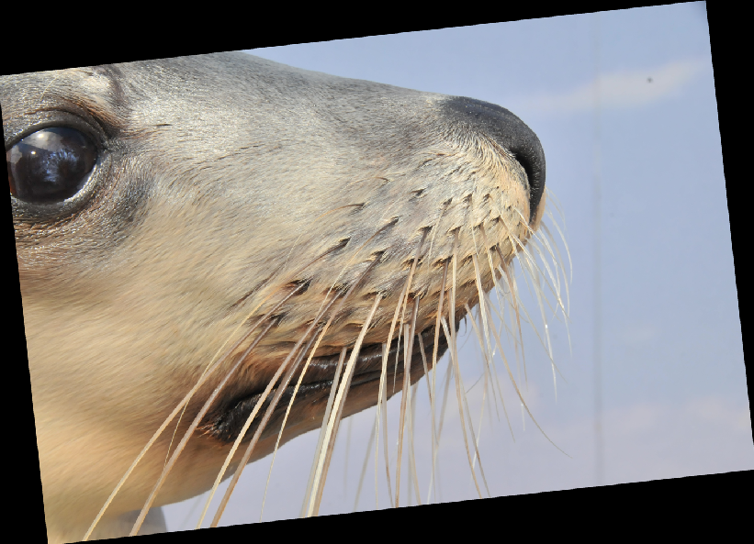

Figure 2. Photo rotated with corner of the eye and nostril as reference points
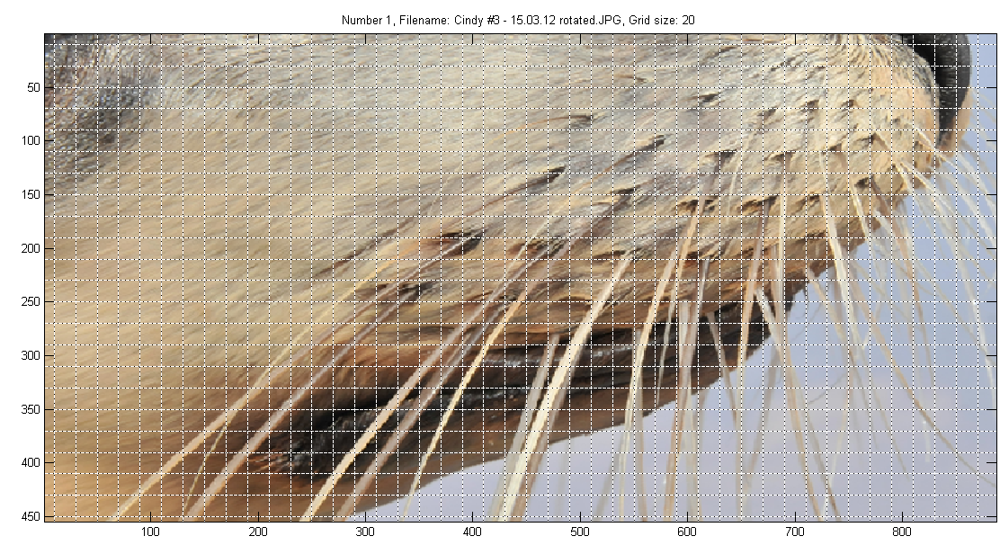
Figure 3. The photo has been resized to 800 Pixel between the two reference points and a grid overlaid

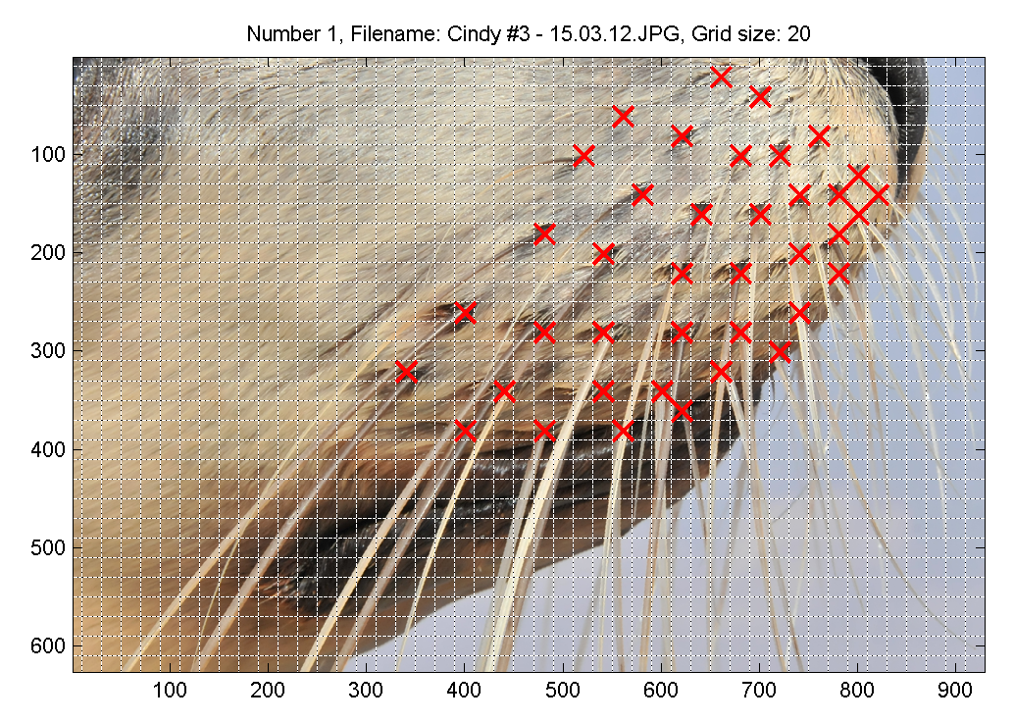
Figure 4. Whisker spots marked with red crosses
Fig

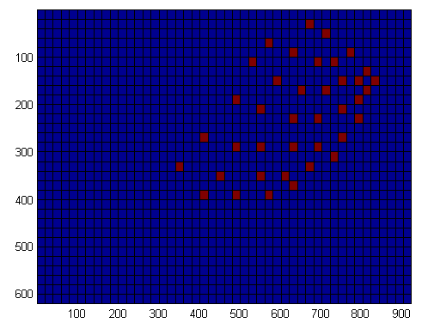
Figure 5. The pattern of presences (red) and absences (blue) of whisker spot patterns in the grid

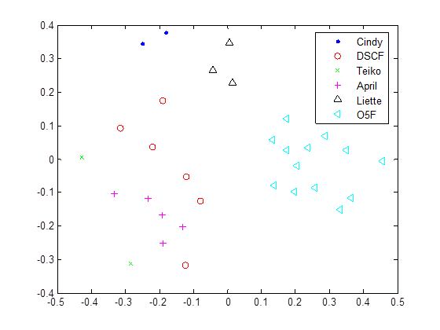
Figure 6. With Iain’s new code, we were able to do some preliminary analyses. We ran a 2D cross correlation to compare the photos and plotted it in a MDS (multidimensional scaling). It basically shows how the photos (sorry for the long photo names) were clustered:

Group 1:  GridSize_20_Cindy #3 - 15.03.12.mat  GridSize_20_Cindy #4 - 15.03.12.mat  Group 2:  GridSize_20_P1030572_Liette.mat  GridSize_20_P1030573_Liette.mat  GridSize_20_P1030574_Liette.mat | Group 5:  GridSize_20_DSC_0903_Teiko.mat  GridSize_20_DSC_0906_Teiko.mat  Group6:  GridSize_20__O5F8753.mat  GridSize_20__O5F8754.mat  GridSize_20__O5F8758.mat  GridSize_20__O5F8763.mat  GridSize_20__O5F8766.mat  GridSize_20__O5F8768.mat  GridSize_20__O5F8781.mat  GridSize_20__O5F8844.mat  GridSize_20__O5F8845.mat  GridSize_20__O5F8848.mat  GridSize_20__O5F8850.mat  GridSize_20__O5F8852.mat  GridSize_20__O5F8854.mat
Group 3:
GridSize_20_DSCF4940.mat
GridSize_20_DSCF4941.mat

Group 4:
GridSize_20_DSCF4934.mat
GridSize_20_DSCF4935.mat
GridSize_20_DSCF4936.mat
GridSize_20_DSCF4939.mat
GridSize_20_DSC_0911_April.mat
GridSize_20_DSC_0915_April.mat
GridSize_20_DSC_0916_April.mat
GridSize_20_DSC_0918_April.mat
GridSize_20_DSC_0919_April.mat

This means that it only mismatched one group, which is a great result for a start :-).

The next step is to text multiple approaches to analyses and refine the analyses to minimise miss-matches.

Hope you are having a great start of the week ☺!!

Talk to you soon,
Sylvia

